**Hoopla digital download instructions for iOS Devices** 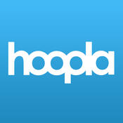

1. **Download free Hoopla Digital app from the App Store**
2. **Sign Up for Account**
   * Search for Gunnison County Library
   * Enter your email and create password
   * Enter your library card number
3. **Search for specific items, or browse the collections of video, music, and books**

Adjust the items that show up in the **Recommended** section by scrolling to the bottom of the page while browsing the Recommended list, or by going to **My Hoopla**, tapping on the gear icon in the top right corner, and then tapping Recommendation Settings.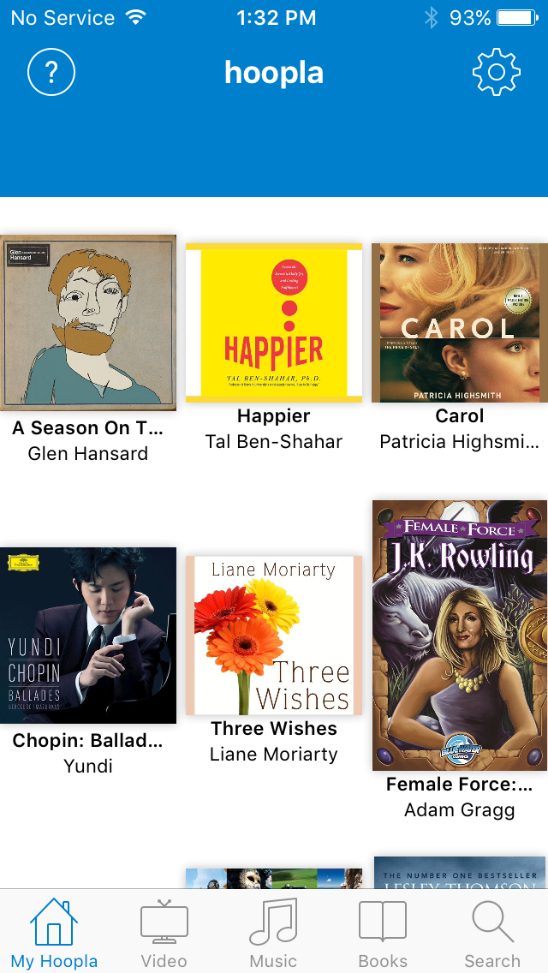

1. **If interested in an item, tap on the cover. A page will pop up allowing you to borrow it. As soon as you tap borrow, the title will begin downloading, and you can find the item in your My Hoopla screen.**

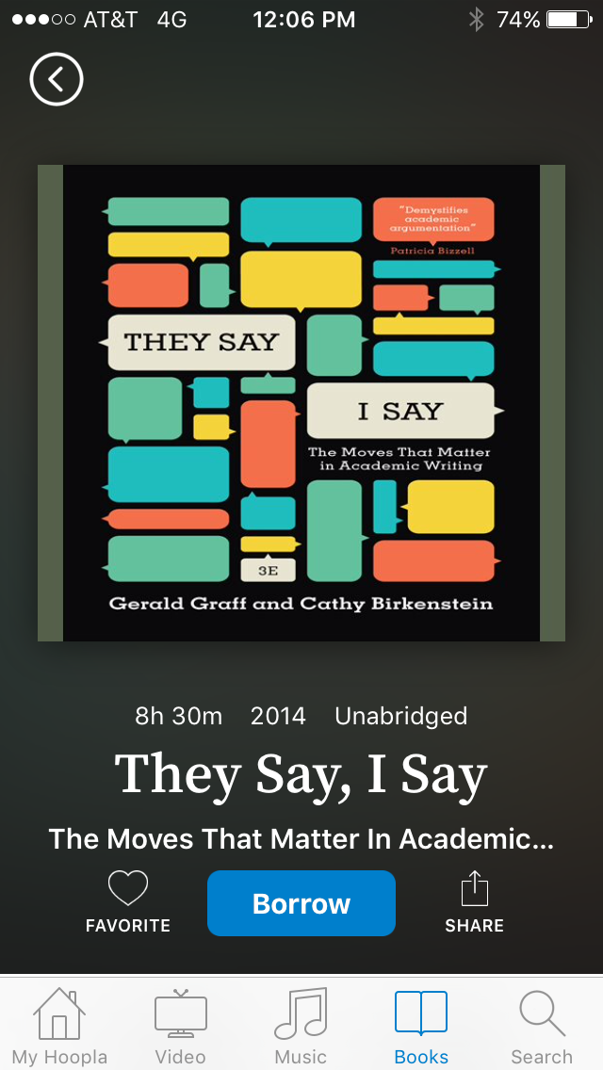

If you just want to learn more about the item, scroll down on the **Borrow** page to read a synopsis and see a list of similar items.

1. **When you are done with an item, you can either wait until its due date, when it will return itself automatically, or you can tap on the item in My Hoopla, scroll all the way to the bottom of the page, and click Return Now.** 
   * Movies and TV shows check out for 3 days
   * Music checks out for 7 days
   * Audiobooks and Ebooks check out for 21 days